

**OUTREACH SCHOOLS EXAMINATIONS BOARD**

**END OF TERM II EXAMINATION 2024**

**P.5 INTEGRATED SCIENCE**

***Time Allowed: 2hours 15 Minutes***

**Pupil’s Name: ………………………………………..……………………**

**Class: ……………………………….………………………………………**

**School Name: …………………………………………………………….**

|  |  |  |
| --- | --- | --- |
| **FOR EXAMINERS’**  USE ONLY | | |
| **Qn. No.** | **MARKS** | **EXR’S**  **No.** |
| **1 - 10** |  |  |
| **11 – 20** |  |  |
| **21 – 30** |  |  |
| **31 – 40** |  |  |
| **41 – 43** |  |  |
| **44 – 46** |  |  |
| **47 – 49** |  |  |
| **50 - 52** |  |  |
| **53 - 55** |  |  |
| **TOTAL** |  |  |

**Read the following instructions carefully:**

1. This paper has two sections: **A** and **B**
2. Section **A** has 40 questions (40 marks)
3. Section **B** has 15 questions (50 marks)
4. Answer all questions. All the working for both sections A and B must be shown in the spaces provided.
5. All working must be done using a blue or black ball point pen or ink. Any work done in pencil will NOT be marked except drawings and diagram.
6. Unnecessary changes in your work and handwriting that cannot be easily read may lead to loss of marks.
7. Do not fill anything in the table indicated

**“For examiners’ use only”** and the boxes inside the question paper.

***Turn Over***

**SECTION A.**

1. Name the body organ which pumps blood.

..........................................................................................................................

1. Give one role of a mother at home.

..........................................................................................................................

1. Name the vector that spreads cholera germs to people.

..........................................................................................................................

1. State one importance of water to plants.

..........................................................................................................................

1. **In the space provided below, draw one item used to keep our classroom-dean.**

|  |
| --- |
|  |
|  |

6. State one way of caring for our teeth.

..........................................................................................................................

7. Write down one example of a perennial crop.

..........................................................................................................................

1. How is an umbrella useful on a rainy day?

..........................................................................................................................

1. State one way in which soil is formed.

..........................................................................................................................

1. Give any one use of flowers to a plant.

..........................................................................................................................**The diagram below shows a garden tool.**



1. State one way of caring for the garden tool above.

..........................................................................................................................

1. Write one way of catching fish from lakes and rivers.

..........................................................................................................................

1. How is a cobbler important in our community?

..........................................................................................................................

1. Why do some objects sink in water?

..........................................................................................................................

1. Give one use of the human urinary bladder.

..........................................................................................................................

1. State one way oxen are useful to people.

..........................................................................................................................

1. Identify one way of managing accidents at school.

..........................................................................................................................

1. Name one set of teeth that develops in human beings.

..........................................................................................................................

1. How do tapeworms enter our bodies?

..........................................................................................................................

1. State any **one** condition necessary for a seed to germinate.

..........................................................................................................................

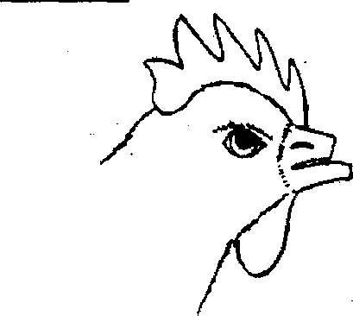**The diagram below shows a head of a hen. Use it to answer questions 21 and 22.**

1. Which practice in poultry keeping is shown above?

..........................................................................................................................

1. Why do poultry farmers carry out the above practice?

..........................................................................................................................

1. Give the importance of humps on a road.

..........................................................................................................................

1. Name one disorder of the digestive system.

..........................................................................................................................

1. Why is it important to give first aid to a person who has suddenly fallen sick or  
   been injured?

..........................................................................................................................

1. How are flowers able to attract moths at night for pollination?

..........................................................................................................................

1. Name one garden tool people can use to harvest cassava.

..........................................................................................................................

1. Give one importance of the sun to people.

..........................................................................................................................

1. Why should a school have a nurse?

..........................................................................................................................

1. Name one material children can use to make ropes for skipping.

..........................................................................................................................

**Use the diagram below to answer questions 31 and 32.**

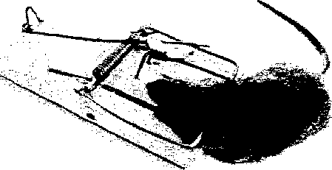

1. Identify the method of controlling pests above.

..........................................................................................................................

1. Name one pest that can be controlled using the above method.

..........................................................................................................................

1. Give one importance of PIASCY messages in primary schools today.

..........................................................................................................................

1. Write any one situation when people must wash their hands.

..........................................................................................................................

1. Name the component of air which is used to preserve drinks.

..........................................................................................................................

1. Identify the system of keeping-poultry shown in the diagram below.

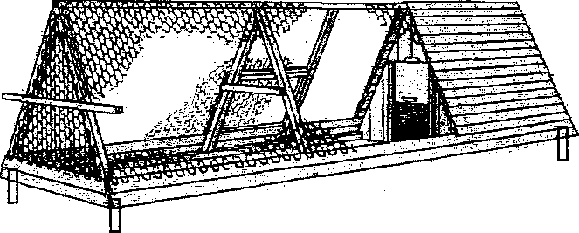

............................................................................................................................

1. How are proteins important in the body?

..........................................................................................................................

1. Why is it advisable to cover your mouth with a handkerchief when coughing?

..........................................................................................................................

1. What is mulching?

..........................................................................................................................

1. Name the enzyme which digests starch in the mouth.

........................................................................................................................

**SECTION B**

1. a) Name the type of chicken that are purposely kept for;

i) Meat production ............................................................................................

ii) Egg production .............................................................................................

b) Give one way of improving local breeds of poultry.

..........................................................................................................................

c) Why is deep litter system of keeping poultry most suitable for commercial purposes?

..........................................................................................................................

1. a) Write ORS in full.

..........................................................................................................................

b) Give two common solutes used in preparing ORS at home.

i)........................................................................................................................

ii)........................................................................................................................

c) What is the importance of ORS to a dehydrated person?

..........................................................................................................................

1. a) Give the function of the following weather instruments.

i) Six’s thermometer ..........................................................................................

ii) Wind vane ....................................................................................................

b) In which weather condition does a rain gauge work?

..........................................................................................................................

c) Why should a rain gauge be put in an open place?

........................................................................................................................

1. **The diagram below shows part of the alimentary canal. Use it to answer question 44.**

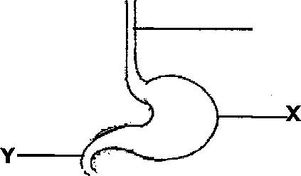

**W**

1. Name parts marked W and Y.

W: ..........................................................................................................

Y: ..............................................................................................

1. Write one function of part marked X.

....................................................................................................................

1. Identify any one disease that can attack the above system.

....................................................................................................................

1. A fuel is any material that burns to produce heat and light.
2. Name any two common fuels used at home.

i)..............................................................................................................

ii) ........................................................................................................

1. Give one use of electricity at home.

............................................................................................................

1. How can a child save resources at home?

............................................................................................................

1. (a) What is immunity?

................................................................................................................

(b) Name any two immunisable diseases that are prevented and controlled by the DPT vaccine.

i) ..................................................................................................................

ii) ....................................................................................................................

c) Give one importance of immunisation in our community.

....................................................................................................................

1. **The table below shows items used for keeping our bodies clean. Complete it correctly.**

|  |  |
| --- | --- |
| Item | Importance |
| Tooth brush | _____________________ |
| ___________________ | Trimming finger nails |
| Sponge | ____________________ |
| ___________________ | Drying our bodies after bathing |

1. (a) Name any two wild animals.

i).................................................................................................................

ii)................................................................................................................

b) How can wild animals be dangerous to people?

...................................................................................................................

(c)Write any one way of caring for wild animals.

..................................................................................................................

1. **The following insects were collected for a science lesson. Use them to answer question 49.**

Grasshopper

Termite

Housefly

(a) Which of the insects above does not have wings?

..................................................................................................................

(b) How is the lifecycle of a grasshopper different from that of a housefly?

...................................................................................................................

(c) How are all the insects above similar?

...................................................................................................................

(d) Which of the insects above spreads germs that cause illness among people?

...................................................................................................................

1. (a)Identify any one type of bee in a hive.

...................................................................................................................

(b) State one importance of bees to people.

...................................................................................................................

(c) Give any two conditions and reasons for swarming in bees.

(i) .......................................................................................................

(ii) ........................................................................................................

1. **Match the words in list A with their meaning in list B.**

**List A ListB**

Mass space occupied by an object.

Density force that pulls objects to the centre of the earth.

Volume mass per unit volume.

Gravity quantity of matter in an object.

(i) Mass .....................................................................................

(ii) Density .....................................................................................

(iii) Volume .....................................................................................

(iv) Gravity .....................................................................................

1. (a) Write two traditional methods of preserving food.

i) ................................................................................................................

ii) ...............................................................................................................

(b) Why do people preserve food in our community?

...................................................................................................................

(c) Identify any one organism that makes our food to go bad.

...................................................................................................................

1. **A P.5 class carried out an experiment about soil. The experiment was arranged as in diagrams below.**

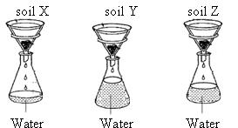

1. Name the type of soil marked X and Z.

X ……………………………………………………………………………………………………………

Z …………………….……………………………………………………………………………………

1. Why did soil marked Y allow more water to pass through it easily?

………………………………………………………………………………………………………………….

1. Give any one use of soil to people.

…………………………………………………………………………………………………………………

1. (a) What is heat?

…………………………………………………………………………………………………………………………..

b) Identify any two sources of heat.

i) …………………………………………………………. ii) ………………………………………………

c) Give any one use of heat at home.

……………………………………………………………………………………………………………………..

1. Why is the handle of a frying pan made of plastic?

……………………………………………………………………………………………………………………..

1. **The diagram below shows a common domestic animal.**

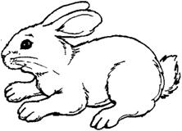

1. Name it.

........................................................................................................

1. Write down any two diseases that attack the animal above.

i)...................................................ii).................................................

1. State any one activity you can do on your farm to prevent and control the diseases in (b) above.

........................................................................................................

**END**